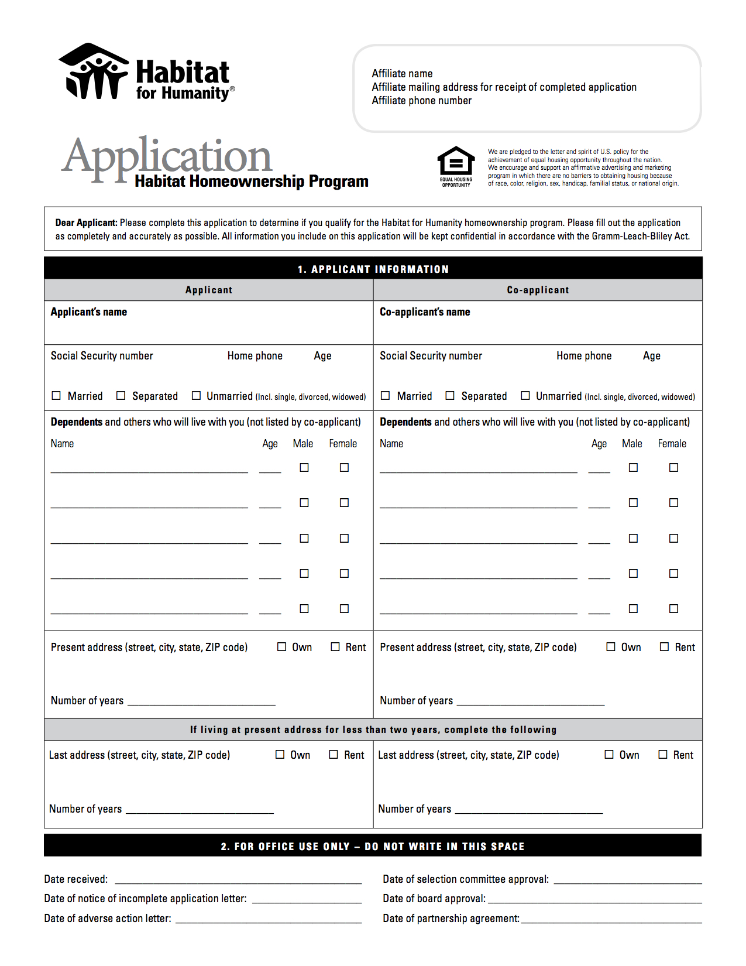

Habitat for Humanity of Clearfield County

P.O. Box 463, DuBois, PA, 15825

www.clearfieldhabitat.com

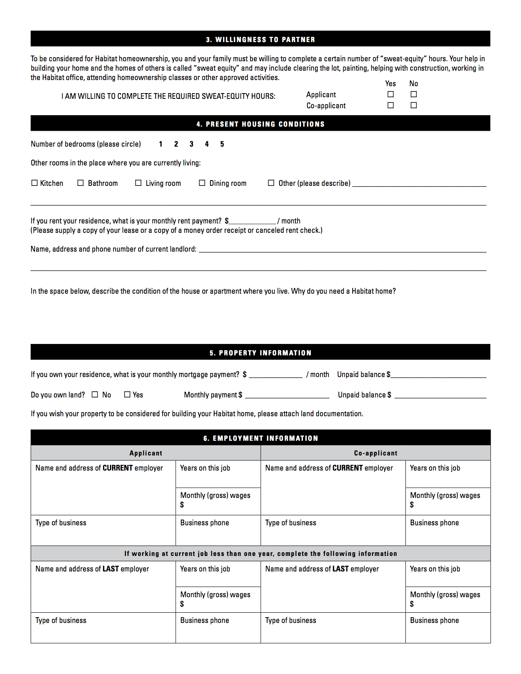

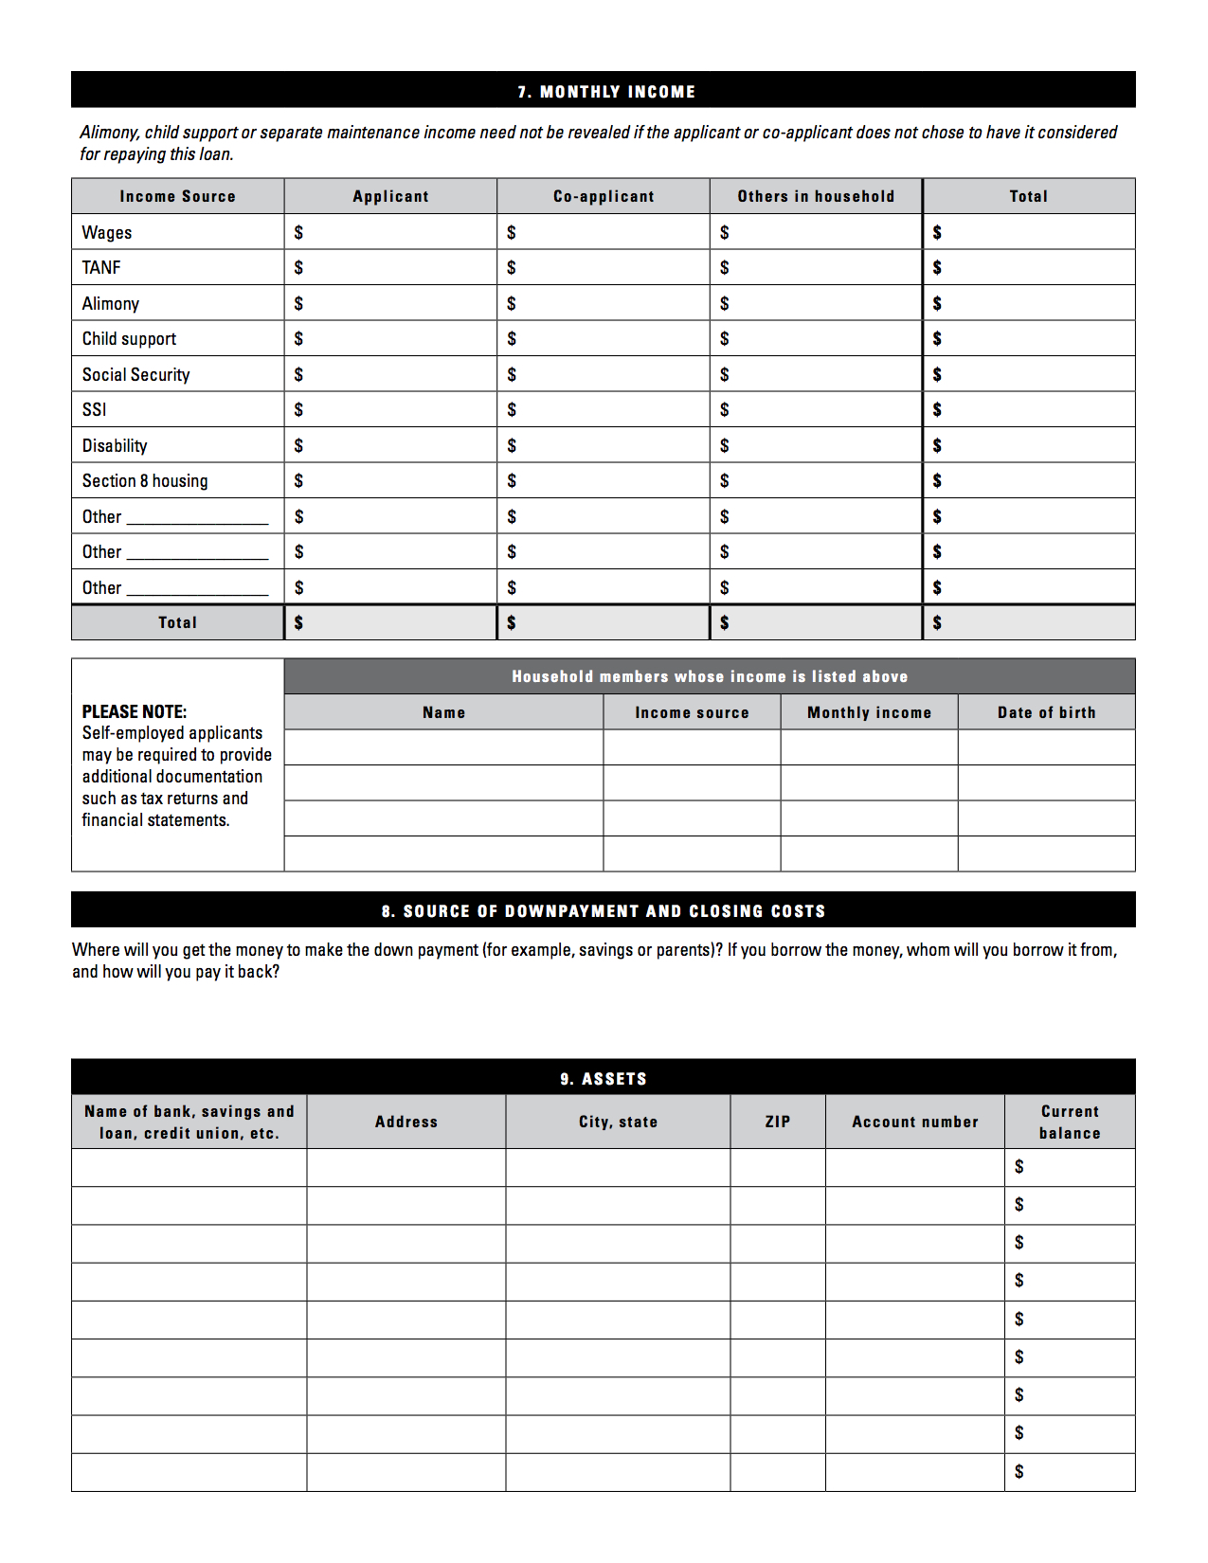

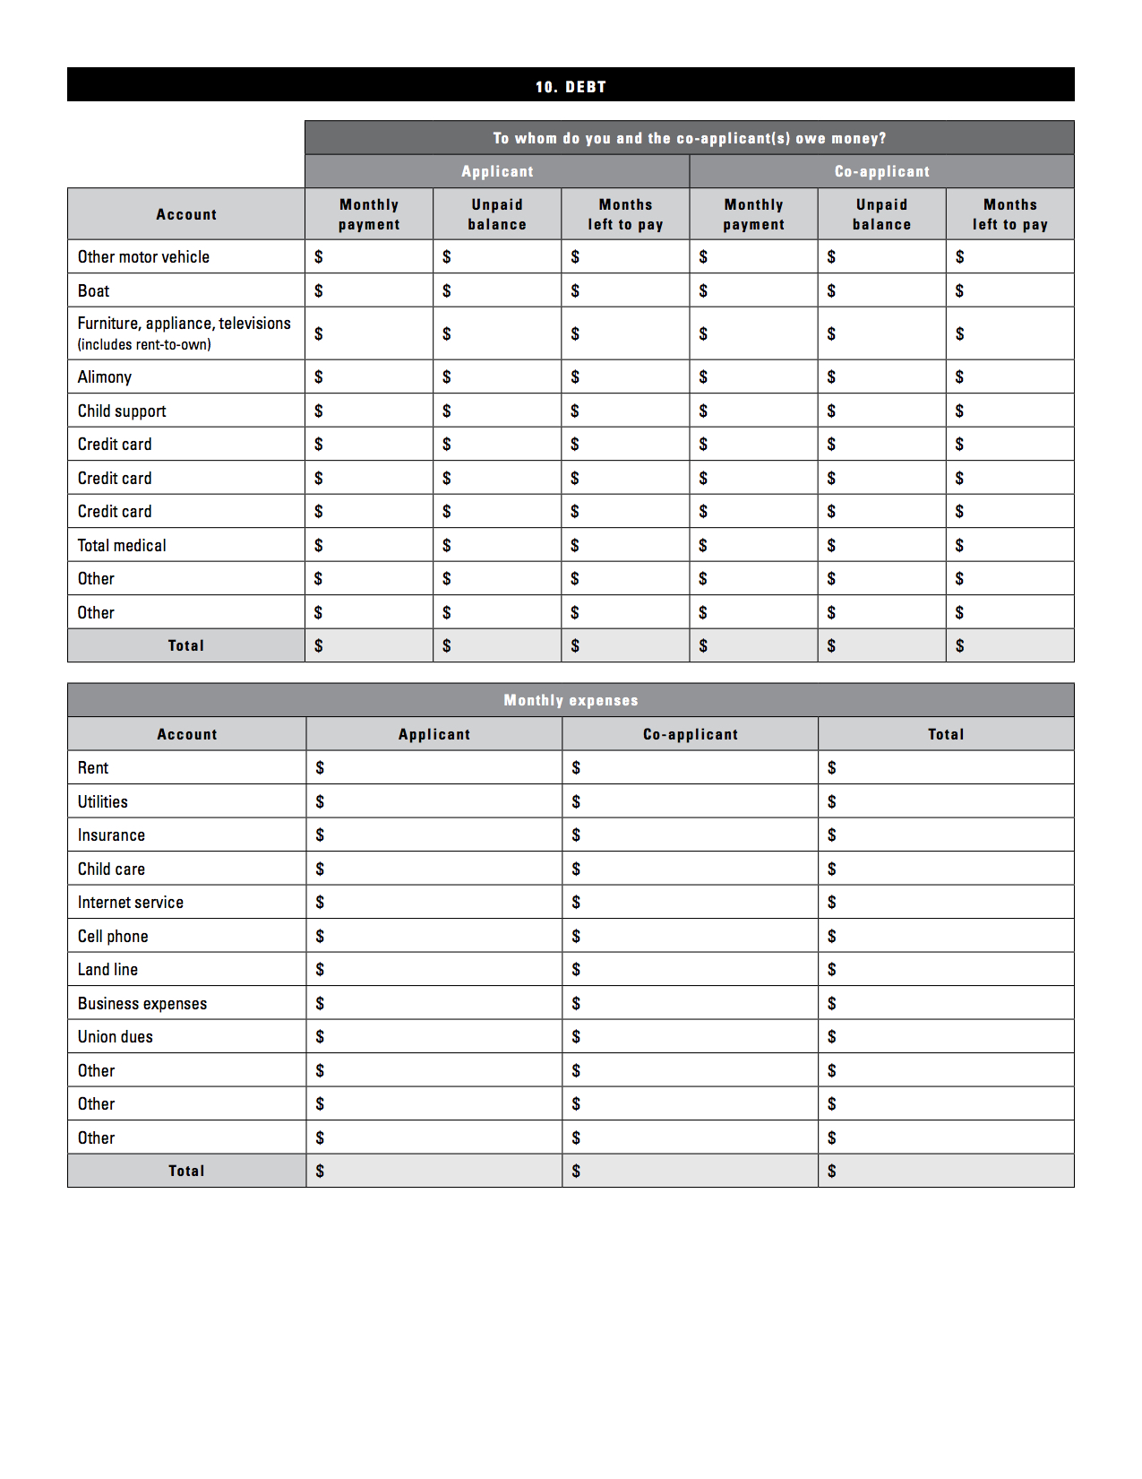

Please note: if you pay monthly on loans (student, car, etc.), include them in the monthly expenses and specify what loan in the ‘Other’ box.

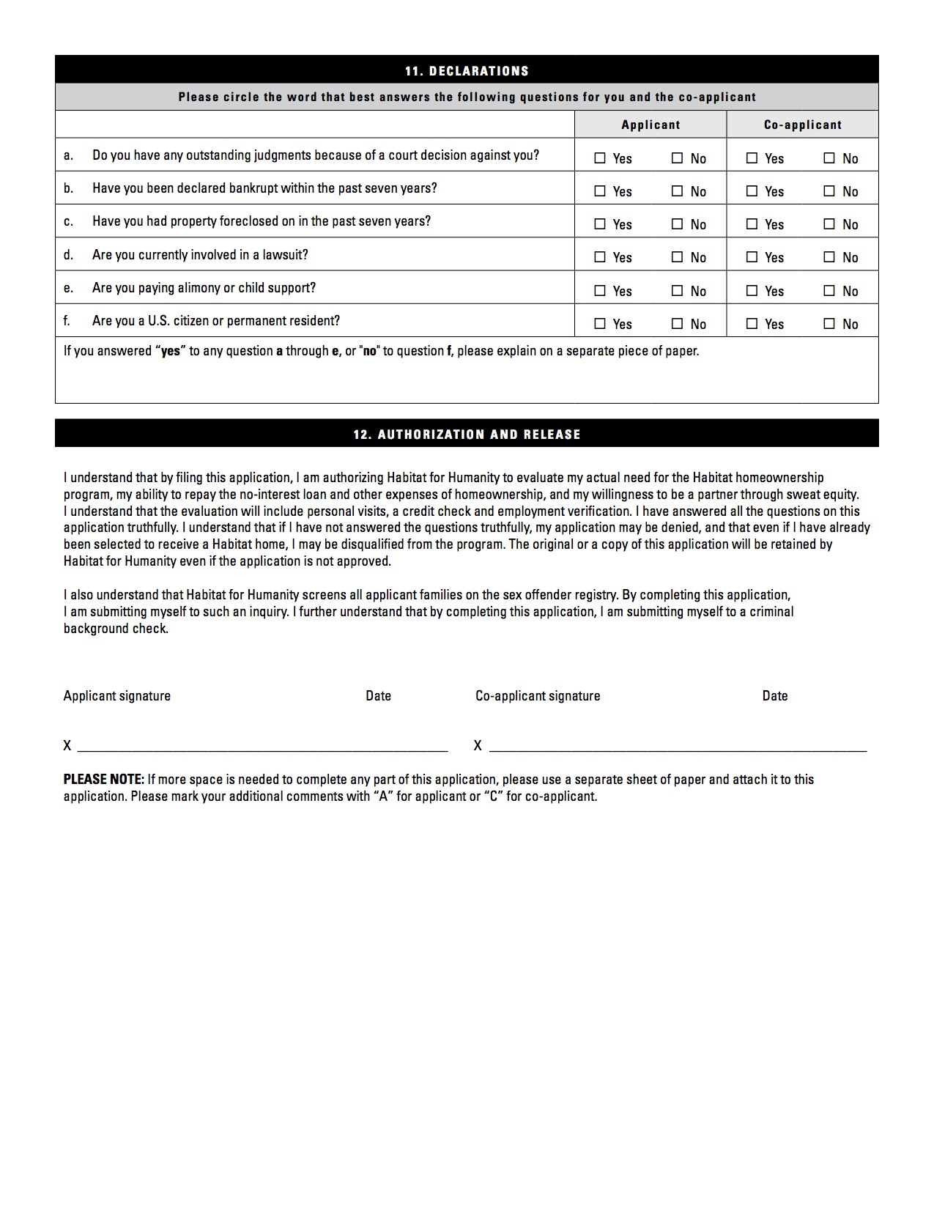

**The applicant(s) release(s) Habitat for Humanity of Clearfield County and its member volunteers and employees, from any and**

**all liability, which may arise in connection with the release of information.**

